**How do you want to add data?**

To add data, click **Add Data**. The Add Data page appears. If your Splunk deployment is a self-service Splunk Cloud deployment, from the system bar, click **Settings** > **Add Data**.

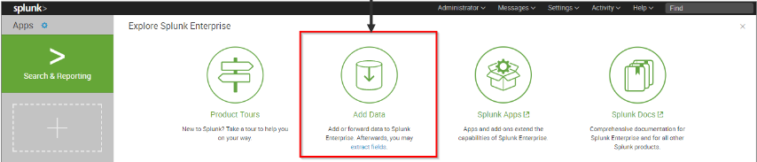

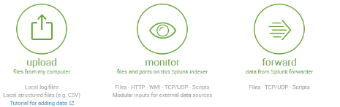

**Upload -> it’s for static data.**

The Upload option lets you upload a file or archive of files for indexing. When you click Upload, Splunk Web goes to a page that starts the upload process. See [Upload data](http://docs.splunk.com/Documentation/Splunk/8.0.1/Data/Uploaddata).

**Monitor -> It’s live data.**

The Monitor option lets you monitor one or more files, directories, network streams, scripts, Event Logs (on Windows hosts only), performance metrics, or any other type of machine data that the Splunk Enterprise instance has access to. When you click Monitor, Splunk Web loads a page that starts the monitoring process. See [Monitor data](http://docs.splunk.com/Documentation/Splunk/8.0.1/Data/Monitordata).

**Can we designed similar tool like splunk-** Yes we can, We need to write API.

Different between notepad and notepad++ -> Look and feel, that value splunk bring in our data.

**SF Installation-** Download SF-> No need to provide SSL details by default Splunk is secure -> Deployment server-> Receiver indexer details.

Starting, stopping and checking status of splunk- [ec2-user@ip-172-31-32-153 bin]$ **./splunk status** plunkd is running (PID: 1292). splunk helpers are running (PIDs: 1298 1311 1475 1513).

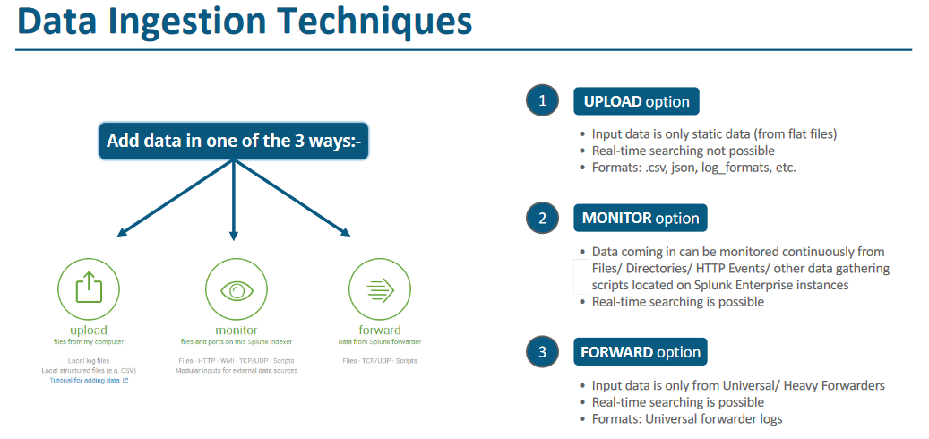

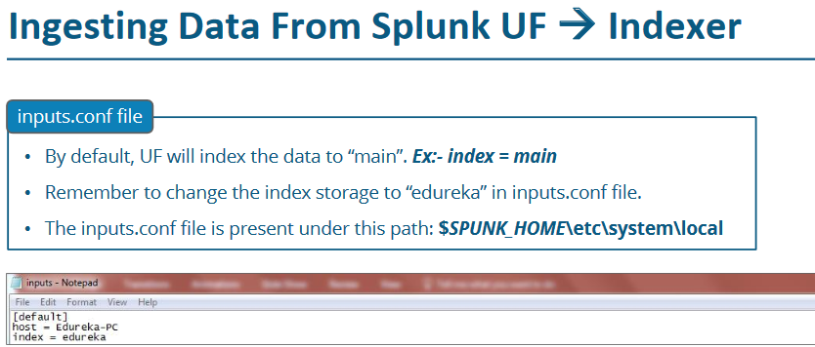

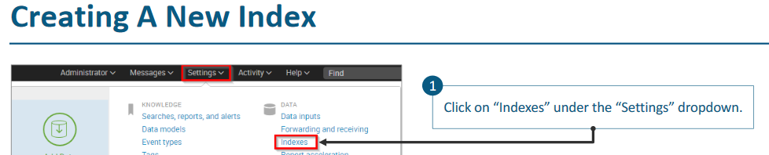

Note- You can search only the indexed data.

**Question- On which file your parsing logic is defined?** Answer: prop.conf file.

**Question: How to install a command from Unix store?** Answer: yum install telnet telnet-server -y

**Question: Default login and password for splunk** Answer: admin/changeme

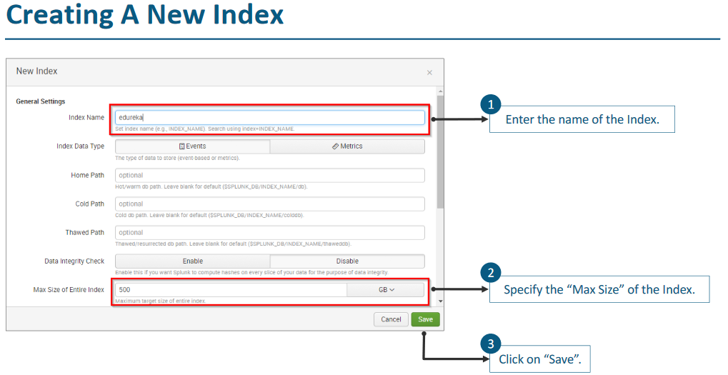

Note- You need to enable port on which splunk UF will be forwarding data.

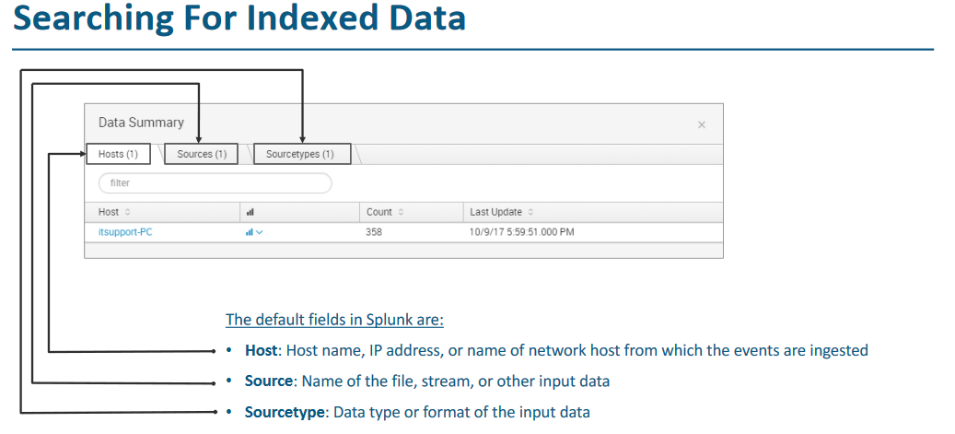

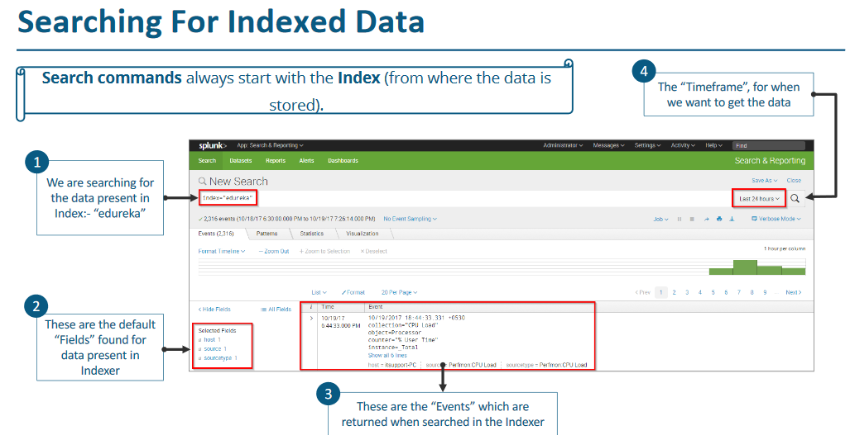

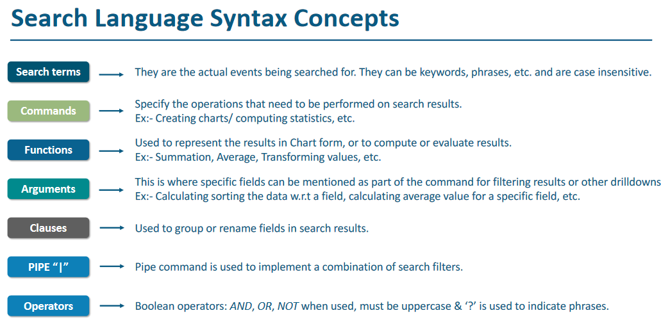

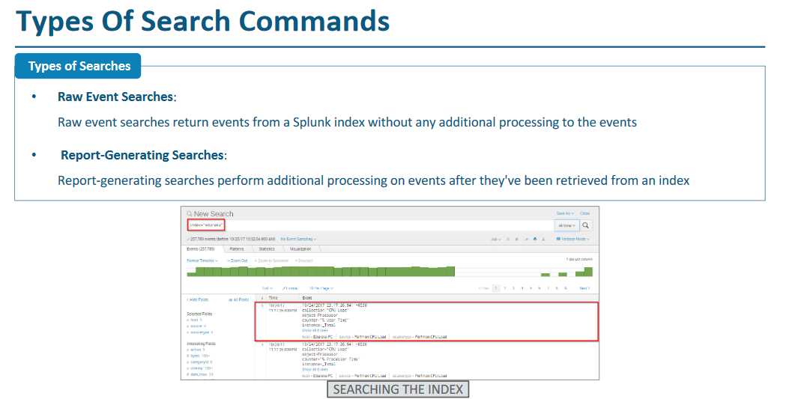

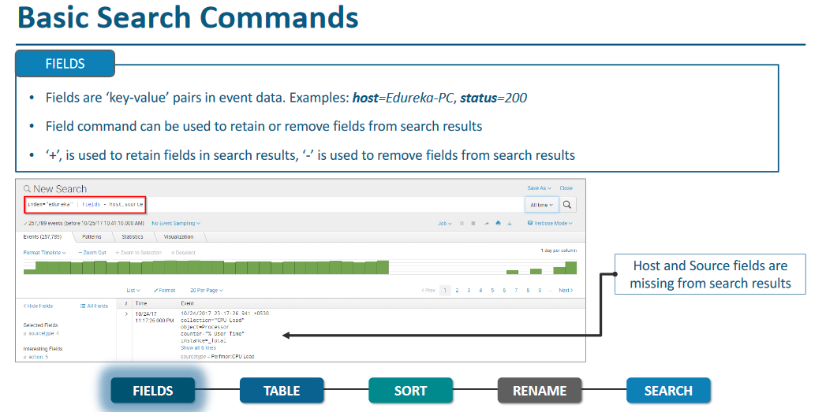

Reporting and transforming command-

